**SRI CHANDRASEKHARENDRA SARASWATHI VISWA MAHAVIDYALAYA**

**(UNIVERSITY ESTABLISHED under section 3 of UGC Act 1956)**

**ENATHUR,** **KANCHIPURAM – 631 561**



**PROGRAMMING IN C LAB**

**LABORATORY RECORD**

**Name : D.RAJLAXMI**

**Reg. No : 112534038**

**Class : I Year BCA-‘A’**

**Subject : <subCode>- PST IN C LAB**

**SRI CHANDRASEKHARENDRA SARASWATHI**

**VISWA MAHAVIDYALAYA**

**(University Established under section 3 of UGC Act 1956)**



**BONAFIDE CERTIFICATE**

**This is to Certify that this is the bonafide record of work done by**

**Ms. D.Rajlaxmi, with Reg.No 112534038 of I Year Bachelor of Computer Applications in the Problem Solving Techniques in C Lab during the year 2025.**

**Staff-in-charge** **Head of the Department**

**Submitted for the Practical Examination held on ________________________**

**Internal Examiner** **External Examiner.**

**INDEX**

|  |  |  |  |  |
| --- | --- | --- | --- | --- |
| **S.No.** | **Date** | **Title** | **Page No.** | **Signature** |
| 1 | 24-07-25 | Celsius to Fahrenheit |  |  |
| 2 | 31-07-25 | Fibonacci Series |  |  |
| 3 | 07-08-25 | Square and Cube of Numbers |  |  |
| 4 | 14-08-25 | Generate Odd Numbers |  |  |
| 5 | 21-08-25 | Generate Grade |  |  |
| 6 | 28-08-25 | Generate Tower |  |  |
| 7 | 04-09-25 | Palindrome or Not |  |  |
| 8 | 25-09-25 | String Handling |  |  |
| 9 | 25-09-25 | Array Sorting |  |  |
| 10 | 9-10-25 | Factorial |  |  |
| 11 | 9-10-25 | Swapping of Numbers |  |  |
| 12 | 23-10-25 | Using Structure |  |  |
| 13 | 23-10-25 | File Programming |  |  |

|  |  |  |
| --- | --- | --- |
| **DATE: 25**-9-25 | **ARRAY SORTING** |  |

**AIM :**

**To write a C program to sort an array**

**ALGORITHM :**

STEP 1 :Declare counter variables (i, j) temprory variable (temp),array to store elements.

STEP 2: Read number ofelement n.

STEP 3 **:** If (n<=0 || n>100) goto step 21 else continue.

STEP 4 : i=0

STEP 5 : Read arr(i)

STEP 6 : If i<n goto step 5 else continue.

STEP 7 : i=0

STEP 8 : j=0

STEP 9 : If arr[j]<arr[j+1] goto step 15 else continue.

STEP10: temp=arr[j]

STEP11: arr[j]=arr[j+1]

STEP12: arr[j+1]=temp

STEP13: j=j+1

STEP14: If j<n-1-I goto step 9 else continue

STEP15: i=i+1

STEP16: If i<n-1 goto step 7 else goto 17

STEP17: i=0

STEP18: Printf arr(i)

STEP19: i=i+1

STEP20: If i<n goto step 18,else goto step 22

STEP21: Print “n value should be 1 to 100”

STEP22: Stop

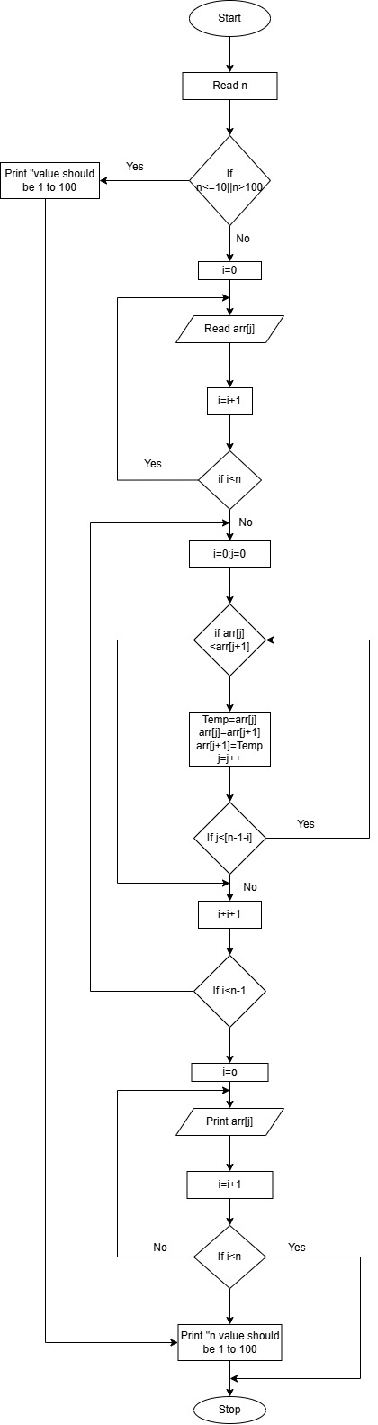**FLOWCHART:**

**SOURCE CODE:**

[c-lab/arraysorted.c at main · rajlaxmi8327/c-lab](https://github.com/rajlaxmi8327/c-lab/blob/main/arraysorted.c)

**OUTPUT:**

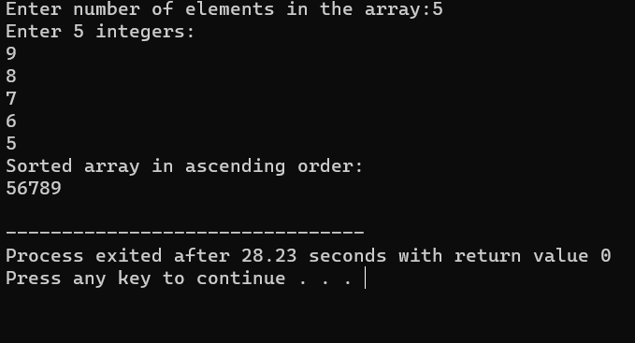

**RESULT :**

**Thus the program is compiled and executed successfully with verified output.**